

**The Relationship between Social Mobility and Professional Commitment in Women Doctors of Punjab**

Name: Khadija Mazher

Roll Number: 243945728

SOCL 599: Final Year Independent Research Project

2024

**Thesis Supervisor: Dr. Sara Rizvi Jafree**

**Department of Sociology**

**Forman Christian College (A Chartered University)**

Contents

Abstract 4

1 Introduction 5

1.1 Problem Statement: 6

1.2 Research Objectives: 6

1.3 Significance of the Research 7

1.4 Definitions 7

1.5 Research Questions: 8

2 Literature Review 9

2.1 Social Mobility of Women: 9

2.2 Professional Commitment: 10

2.3 Challenges faced by women doctors: 10

2.4 Patriarchal culture: 11

2.5 Work-family Conflict: 11

2.6 Role burden 12

3 Theoretical Framework: 14

3.1 Gender Role Theory: 14

4 Methodology 17

4.1 Research Design: 17

4.2 Hypothesis: 17

4.3 Ethical Consideration: 18

4.3.1 Privacy and Confidentiality: 18

4.3.2 Data Security: 18

4.3.3 Voluntary Participants: 18

4.3.4 Informed Consent: 18

4.4 Sample design: 18

4.4.1 Selection Criteria: 18

4.4.2 Sampling Method: 19

4.5 Instruments: 19

4.5.1 Beliefs about Social Mobility: 19

4.5.2 Professional Commitment: 19

4.5.3 The Work-Family Conflict & Family-Work Conflict: 20

4.6 Data Collection: 20

Table 1: 20

4.7 Data Analysis: 21

5 Results 22

Table 2 22

Table 3 23

Table 4 25

Table 5 26

Table 6 27

Table 7 28

Table 8 29

Table 9 30

6 Discussion 31

7 Concluding Recommendation 34

8 References 36

Appendix A: IRB Certificate 42

Appendix B. Informed Consent Letter 43

Appendix C. Permission Letters 44

Appendix D. Questionnaire 47

Section 1: Sociodemographic 47

Section 2: Social Mobility Scale (Browman et al., 2017) 47

Section 3: Professional Commitment Scale by Meyer and colleagues (1993) 48

Section 4: The Work-Family Conflict Scale (WFC) by Netemeyer, Boles and McMurrian (1996) 48

# 

# Abstract

In the context of this study, the social mobility of women refers to the upward and downward movement of women in society specifically for social and economic standing. In Pakistani society, women doctors face challenges and barriers to their social mobility due to the patriarchal culture. Women doctors’ professional commitment, job commitment, and overall output quality as care providers are influenced adversely by their lack of social mobility. In addition, Pakistani women doctors suffer from work-family conflict and role burdens which can prevent their social mobility and level of professional commitment. This research aimed to (i) find out the relationship between social mobility and professional commitment in women doctors, and (ii) the influence of work-family conflict on social mobility and professional commitment of women doctors. In this study the nature of the research design was quantitative. A sample of 200 currently working women doctors were sampled from both public and private hospitals in three cities of Punjab. Data was analyzed statistically through the software SPSS. For data collection standardized scales were used, including: The ‘Beliefs About Social Mobility Scale by Browman and colleagues (2019)’, ‘The Commitment to Organization scale by Meyer and colleagues (1993)’, and ‘The Work-Family Conflict by Netemeyer and colleagues (1996)’. Multiple Linear Regression disclosed that (i) the higher social mobility, the higher the professional commitment [F (11, 197) = 6.318, p< 0.000], (ii) the higher the work-family conflict, the lower the social mobility [F (11, 196) = 3.141, p< 0.008], and (iii) the higher the work-family conflict, the lower the professional commitment [F (11, 193) = 3.263, p> 0.878]. The findings can be used to plan better policy protection, social support, and employer support for women doctors, which would have wider implications on professional retention, job satisfaction, and commitment and care provided to patients and families

## 1 Introduction

Women’s Social mobility is defined as; ‘the ability of women to move up and down the social and economic ladder within a society’ (Sorokin, 2019). This study aims to find out the factors that hinder women's abilities and affect them to commit to their profession effectively. In Pakistan the ratio of women students in medical colleges is higher than men students in medical colleges and when looking at the practical field it is observed that 50% of women medical students quit their careers after completing their course work. This creates a vast gap in the practical field. Pakistan is a developing patriarchal society in which no doubt working women in all professional fields face many hurdles and barriers. However, through an increase in literacy rate and through social media campaigns the situation becomes favorable for women but still, they face challenges regarding moving upward on the ladder of social mobility. This study shed light on gender roles and how these roles shape attitudes toward women's behavior and limit their role within society. In Pakistan, women are considered to do household tasks. All decisions related to women (education, marriage, empowerment) are made by the senior male member of the family. Women doctors in Pakistan despite being specialized professionals face challenges to their social mobility and find hurdles in continuing their jobs and their choice to continue work in the specialization of their own choice (Ahmed et al., 2021).

Professional commitment refers to the psychological bonding and beliefs of an employee to accept the goals of the profession and maintain a position with the profession (Meyer & Allen, 1993). Upward social mobility impacts positively on the professional commitment of an employee and an employee’s emotional bounding and beliefs to the career goals become stronger. In the situation of women doctors who play their roles as wives, mothers, and professional doctors experience much workload which affects their ability to manage and perform properly in their personal and professional lives.

## **1.1 Problem Statement:**

In a patriarchal society, women socialized to accept the decisions of the men because they are dominant to them even men control the living patterns of the women (Ashraf and Ali. 2018). Although through social media and awareness campaigns, in medical colleges a large number of women enrolled for under graduation after completing their degrees 50 % of women quit their careers. Other 50% of graduate women doctors who start their career face many challenges in balancing their career and family life. These challenges have an impact on women doctor’s social mobility and professional commitment. There is a need to understand how social mobility positively impacts women doctors’ professional commitment and the factors or barriers that have a negative impact on women doctors’ social mobility and their professional commitment in a patriarchal society.

## **1.2 Research Objectives:**

The aim of this research is to inquire about the association between social mobility and professional commitment in female doctors. How upward social mobility has a positive impact on women doctor’s professional commitment. The factors that work as challenges or barriers to women's social mobility have a negative impact on their level of professional commitment.

## **1.3 Significance of the Research**

Women doctors play a significant role in a developing patriarchal society like Pakistan. In Pakistan, it is crucial to understand the importance of women working doctors and their status and the challenges faced by them in pursuing their profession effectively.

The study on working women doctors has significance in the patriarchal structure of Pakistan, women doctors in the health sector play a crucial role with their experience in professional settings. This study will shed light on women doctors’ roles, their importance in society, and factors that affect women doctors’ ability to pursue their careers and bring change in their social status. This will also highlight how an increase in women doctor’s upward social mobility impacts positively their professional commitment. By understanding women doctors’ role in the healthcare sector and the challenges faced by them in their personal and professional lives, this study will help policymakers in shaping social support policies for women doctors in Pakistan. This study will contribute to providing a supporting environment in a professional setting eliminating the barriers faced by female doctors. This study will be essential to establish better employment opportunities and policies for female doctors in Pakistan and have broader impacts on the quality of human resources in health sectors.

## **1.4 Definitions**

**a) Social Mobility**

Pritim A Sorokin was the first to introduce the concept of ‘Social Mobility’, according to him social mobility is the movement of an individual, families, and groups from one social status to another social status. This social mobility could be horizontal mobility, vertical mobility, upward and downward mobility through a system of social hierarchy, and social stratification (Sorokin, 1927).

**b) Professional commitment:**

Professional commitment is defined as an individual’s psychological bond to accept the beliefs of his profession and willingness to remain in his position in his profession. This professional commitment can be measured with three distinct components (i) affective professional commitment, (ii) continuance professional commitment and (iii) normative professional commitment (Meyer & Allen, 1990).

**c) Work-Family Conflict:**

Work-family conflict is defined as the burden of professional responsibilities and personal life responsibilities of an individual and he fails to maintain a balance between these responsibilities.

**d) Patriarchal Culture:**

Patriarchal culture is defined as a male-dominated culture where women are considered to be excluded from social, political, and economic powers and bonded to less-paid workers as compared to men (Nash, 2020).

## **1.5 Research Questions:**

1. How does social mobility affect professional commitment in women doctors?

2. What is the influence of work-family conflict on social mobility and professional commitment of women doctors?

# 2 Literature Review

With a specific focus on the existing knowledge related to the research topic, this chapter will look thoroughly at the relationship between social mobility and the professional commitment of women doctors in Pakistan. To gain a better understanding and insight knowledge about the topic other authors and scholars' work can help in this study to pinpoint the elements related to the challenges faced by women doctors in Pakistan. Medicine is a notable profession and in Pakistan many women as compared to men enrolled in medical colleges and most of the women physicians quit their careers after completing their graduation (Zaheer, 2022).In all over the world women in a large number enroll in medical education as compared to men (Moazam & Shekhani, 2018).

## **2.1 Social Mobility of Women:**

Social mobility refers to the transfer in one’s social status, this transfer could be in the form of wealth, position, education, science, and religion that has value by the society (Budiati & Rochmat, 2020). Social mobility is a debated concept in relation to gender because women face many hurdles with their social mobility (Ahmed et al., 2021). Tahir (2020) also emphasize on it that in Pakistan women doctors face challenges in achieving upward social mobility. High education and high income are a few of the important factors in achieving high positions and upward social mobility for working women (Zafar, 2019). Gloster, et al., (2019) also in view that higher education and high income a key factors to going up the ladder of social mobility.

## **2.2 Professional Commitment:**

Researchers are more interested in knowing about the professional commitment phenomenon and the employees’ interest and emotional bounding toward their careers (Chang, E. 1999). Professional commitment is defined as the emotional attitude and beliefs of the employees towards their career and Affective Professional Commitment (APC) is defined as an employee’s willingness to stay with his profession (Meyer & Allen, 1996). Here, we can assume through this definition that professional commitment is the emotional bonding of an employee with his career goals (Lee et al., 2000). Literature also shows that an employee’s higher engagement in his career or organization may have a positive impact on his performance and lower his intentions to turnover (Chen & Francesco, 2000). Furthermore, it is also observed that a supporting organization also impacts positively on women doctors’ level of professional commitment (Ilyas et al., 2022). Affective commitment plays a strength in women doctors’ identification with their careers (Cho & Huang, 2012). Women doctors who have strong beliefs and acceptance of their career goals and have a strong desire to continue their careers have a high professional commitment (Yulianti & Fitdiarini, 2022). (Morrow & Wirth, 1989) argues that professional commitment is that the strength of one’s involvement with his profession. Women doctors invest their productivity and choices in terms of maintaining their mutual relationship with their profession (Hoff, 2000).

## **2.3 Challenges faced by women doctors:**

In Pakistan women doctors face numerous constraints such as violence, work-family conflict, and role-burden; yet few research works have been done related to social mobility (Jafree, 2020). Another contributing factor to the low social mobility of professional women is cultural norms, which increase their responsibilities after marriage, and depend on their husbands. (Umer & Rehman, 2013). When we talk about professional commitment, we can assume that stress is also an affecting factor for working female doctors. Female doctors experienced high-stress levels due to workload and less job satisfaction (Syed et al., 2018). In Pakistan women doctors face several challenges, including role burden, organizational discrimination, and work-family conflict (Massod A, 2019). These multiple roles create hurdles for women doctors in balancing their personal and professional lives (Asad &Masood, 2022). There are many contributing factors to these hurdles such as a lack of organizational support, and family expectations (Sandhu & Mehta, 2006). Moreover, women doctors who have full-time jobs and also have children face more work-family conflict (Sheikh, et al.,2018).

## **2.4 Patriarchal culture:**

Despite being specialized women doctors in Pakistan which is a patriarchal society, face barriers to their social mobility that prevent them from continuing their training and their choice to work (Ahmed et al., 2021). It is preferred for women in Pakistan to stay in the four walls of the home and perform household duties (Hakim & Aziz, 1998). Patriarchal customs strengthen and exist in society both male and female (Hook, 2013). It’s a historical construct that exists and is responsible for inequalities between men and women from the beginning of human society (Habiba et al., 2016). Moreover, patriarchal culture is a favorable factor in creating a male-dominant culture that hinders the social and economic growth of women (Ahmed, et al., 2021). In a patriarchal culture it is difficult for women doctors to create balance in their career advancement and personal marital life (Raukar & Mishkin, 2020). Patriarchy is a factor to creates gender-based inequality in the medical profession (Masood, 2019).

## **2.5 Work-family Conflict:**

Especially married women in a patriarchal society have more responsibilities. Working women doctors find work-life balance issues as they have the triple burden of looking after their children and parents-in-law and at the same time doing jobs (OECD, 2018). Married women doctors experience work-family conflict due to their busy careers working long hours at work and incompatible schedules (Pleck, 1980). Due to this conflict most women doctors end their careers (Iqbal, et al. 2022). Like other professions work-family conflict after marriage in Pakistan restricts women doctors from joining their careers (Moazam & Shekhani, 2018). Literature shows that work-family conflict is a major barrier for women doctors that has negatively impacted and affected women doctors’ responsibilities at work and personal life (Alhazemi & Ali, 2016). (Syed, et al., 2018) also explore a positive relationship between work-family conflict and job stress. Due to this stress women doctors have compromised their responsibilities as professional women doctors and as mothers (Noor, et al., 2021). All these compromises have a significant effect on women doctors’ professional productivity and success and their personal lives (Treister-Goltzman, & Peleg, 2016). Work-family conflict is observed in all society as a negative factor for women doctors because it creates hurdles for them to continue their profession (Mehboobi & Imran, 2019). It is also observed that women doctors who work for long hours and do not get support from their husbands face work-family conflict (Khursheed, et al., 2019).

## **2.6 Role burden**

Women doctors experience role burden challenges due to the expectations of their families and societies and the requirements of their careers which demand time and effort (Masood, A. 2017). Women's double roles at home and at work have a negative impact on their interests which results in low productivity, low income and insecure workplace (Ashraf & Ali, 2018). There are many factors, sociocultural and individual that influence working women doctors in continuance of their careers cause a gender gap in society and bind women in domestic roles (Syed & Ozbilgin, 2009). It is a complex issue for women doctors in Pakistan because they suffer from it, which affects their productive ability badly and they fail to balance their professional and personal lives (Asad, 2022).

In conclusion a detailed literature review shows that women doctors face many hurdles and challenges in pursuing and continuing their careers. For women higher education is a key factor in advancing their careers and going up on the ladder of social mobility (Malik & Courtney, 2011). Women doctors face long working hours and manage their professional and personal lives. (Masood, 2019) shed light on the complexities of patriarchal culture which hinders women doctors’ abilities in career advancement. Furthermore, women doctors in a patriarchal culture face work-family conflict challenges in pursuing their career advancement (Masood, 2019). Most of the women doctors face an issue related to pursuing their career advancement, which is lack of family support (Noor, et al., 2021). Masood (2019) is also in supporting view of the lack of familial support and patriarchal culture major issues faced by women doctors. Literature shows women doctors have challenges and barriers in pursuing their careers there is a need to do practical solutions for women doctors to overcome these challenges and pursue their careers effectively (Fatima, et al., 2014). All these barriers hinder women doctors’ abilities in achieving leadership positions (Iftikhar, et al., 2023). Asad, (2022) also suggest coping strategies to reduce these challenges for women doctors in pursuing their profession and reduce work-family conflict. A brief literature review sheds light on the challenges faced by women doctors and also highlights the need to take steps to solve or reduce all these barriers because women doctors have their own importance in the medical profession.

# 3 Theoretical Framework:

## **3.1 Gender Role Theory:**

In a patriarchal society, women face inequalities and discrimination especially in relation to class and ethnicity (Barret, 1980). Social Psychologist Alice H. Eagly made a major contribution to gender role theory. Gender role theory argues the division of labor between two sexes and this division is based on culture (Eagly, 1987). Gender roles are socially and culturally constructed roles between men and women which distinguish the differences between the two sexes, in a patriarchal society men consider having superior rights than women and it is the responsibility of women to obey their decisions with no objection. Gender roles have a strong influence on self-concept, through this division, individuals conceptualize themselves as man and woman. Women are socialized as communal, they behave friendly and as facilitators which shapes their communal activities like child-rearing, a nurturing behavior, and associated with women's responsibility to rear their children.

This theory relates to this study in this term that Pakistan is a patriarchal society and a vast gender gap exists. And working women especially face many hurdles due to this patriarchal structure. This theory helps in this study to understand the constraints faced by working women doctors which effect negatively to their social mobility. It also helps in understanding how patriarchal structure influences women doctors' career effectiveness and their choice to continue their careers. In the domain of behavior patterns of men and women, this theory helps to understand this societal construct deeply. And also helps us to understand the working women doctors' difficulties as a housewife and as a professional doctor.

This theory revolves around gender stereotypes, which is important to understand in the dimension of this study. How gender stereotypes play a vital role in the field of medicine. These are the beliefs about men's and women's attributes. In the medical profession, gender stereotypes help us to understand how men and women differ in their professional roles and what challenges and barriers are faced by women doctors in the progress of their profession. Gender stereotypes help to understand the women doctors’ position at the hospital they hold high positions or not or what type of issues they have in holding high positions as compared to the men's doctors. Social roles are influenced by the gender stereotypes that exist in the daily life of an individual.

In a society men's and women's roles are defined by these gender stereotypes. In a patriarchal society, it is important to understand the challenges of a working women doctor to understand the gender stereotypes. The gender stereotype of women's leadership is typically odd because women are considered for communal roles and the leadership roles are for men. Thus, this study focuses on the relationship of social mobility and professional commitment in women doctors gender role theory helps to understand the women doctors' professional progress and the hurdles and challenges they face in a patriarchal society. Which inequalities women doctors face in their profession and how work-family conflict affects them. Because women socialized for communal roles, staying at home and rearing children. Patriarchal culture does not support working women. Women doctors have tough professional routines to take care of patients at hospitals and also have responsibilities for their household, family, and children. these all create hurdles and challenges for women doctors in balancing their professional and personal lives.

To conclude this theory, in a patriarchal society women doctors face many issues, and the gender role theory helps to understand the circumstances and ideology of social roles and gender role stereotypes. Furthermore, gender role stereotypes also help to understand how a patriarchal culture favors men's leadership roles as compared to women's, and this favors gender inequality in the medical profession. Moreover, these gender stereotypes also help to understand the work-family conflict and role burden issues faced by women doctors. Women doctors have a tough routine because they play a dual role as professional doctors and as wives and mothers in their lives.

This theory addresses all contexts of roles and role stereotypes and how society creates differences on the basis of sex differences between men and women. Sex, religion, and culture are responsible for determining gender behaviors. According to this theory, women have caretaker roles, and men have breadwinner roles. The difference between men's and women's roles is known as gender stereotypes which are directed by the expectations of society. In a patriarchal society, women doctors' challenges and barriers can be understood more effectively through this theory.

# 4 Methodology

## **4.1 Research Design:**

This research was based on a quantitative research design. A survey-based questionnaire was used to collect data.

The independent variable (IV) for this research is ‘Social Mobility’ and ‘Work-Family Conflict’ and the dependent variable (DV) is ‘Professional Commitment’.

## **4.2 Hypothesis:**

H1: The higher the perceived social mobility the greater the professional commitment in women doctors.

H2: The higher the work-family conflict the lower the social mobility and professional commitment of women doctors.

## **4.3 Ethical Consideration:**

All ethical considerations were considered. Informed consent was obtained from all respondents and all information was kept confidential, no identification information was taken, and respondents were assured their right to withdraw at any point.

### **4.3.1 Privacy and Confidentiality:**

In ethical considerations anonymity (respondents' names and personal details) were prioritized during data collection, analysis, and reporting. The data has been saved securely and protected, only researchers have access to this data.

### **4.3.2 Data Security:**

In this research consent or survey forms were used to collect data and this document was kept secure from unauthorized access and the researcher has access to this data.

### **4.3.3 Voluntary Participants:**

Respondents in the research participated voluntarily, they have the right to withdraw at any stage without any negative consequences.

### **4.3.4 Informed Consent:**

All women doctors who were the respondents of this study were provided a consent form with brief and clear information about this study, the aim of this study, and their participation in this study as voluntary (Appendix B).

## **4.4 Sample design:**

### **4.4.1 Selection Criteria:**

For this study women doctors currently working in both public and private hospitals in Punjab were eligible for participation.

### **4.4.2 Sampling Method:**

Through convenience sampling working women doctors were approached from both public and private hospitals in three cities of Punjab- Lahore, Gujranwala, and Wazirabad. The target population for this study was 200 working women doctors.

## **4.5 Instruments:**

For this research three internationally standardized scales were used: (i) the ‘Beliefs About Social Mobility Scale by Browman and colleagues (2019)’, (ii) the ‘Commitment to Organization scale by Meyer and colleagues (1993), utilizing the effective professional commitment dimension’, and (iii) ‘The Work-Family Conflict Scale (WFC)’ by Netemeyer, Boles and McMurrian (1996)’. The first section of the questionnaire consisted of demographic questions (Appendix C).

### **4.5.1 Beliefs about Social Mobility:**

This scale has been designed to assess the perception of the respondent regarding their status to understand their beliefs about social mobility. In this study, the scale ‘Beliefs about Social Mobility’ developed by AS Browman and his colleagues (2019) was used and this scale comprises 8 items to assess the perception of working women doctors about their status in society. Responses were measured on a 5-point Likert scale Strongly agree (socre5) to strongly disagree (score1). A higher score indicates respondents achieved or experienced social mobility.

### **4.5.2 Professional Commitment:**

In this study, the scale of ‘Affective Commitment to Profession’ by Meyer and Allen (1993) was used to assess the emotional attachment, identification, and involvement of working women doctors in their profession. This scale comprises 5 items. Responses were measured on a 5-point Likert scale Strongly agree (score 5) to strongly disagree (score 1). Higher scores indicate greater experience to the professional commitment of the respondents.

### **4.5.3 The Work-Family Conflict & Family-Work Conflict:**

To assess the challenges faced by working women doctors in managing their personal family life and their career requirements the scale ‘The work-family conflict & family-work conflict scale’ was used. This scale was developed by Netemeyer and his colleagues (1996) to assess the interference of work with family and family with work. The scale comprises ten items. Likert scale 5 points Strongly agree (score 5) to strongly disagree (score 1) was used to measure the responses. A higher score indicates that the respondents experienced greater work-family conflict.

## **4.6 Data Collection:**

Data were collected from both public and private hospitals in three cities of Punjab province Lahore, Gujranwala, and Wazirabad based on permission. The data collection was done in the month of December 2023 in the hospital setting, during the working hours of public and private hospitals presented in Table 1.

### **Table 1:**

Targeted Hospitals in Lahore, Gujranwala and Wazirabad where data was collected.

|  |  |  |  |  |
| --- | --- | --- | --- | --- |
| Cities | Public Hospitals | No of Respondents | Private Hospitals | No of Respondents |
| Lahore | Govt Mayo Hospital | 10 | Gurki Trust Teaching Hospital | 5 |
| Govt Nawazshrif Hospital | 5 | Ayesha Saddiqa Hospital | 5 |
| Services Hospital | 5 | Fatima Memorial Hospital | 10 |
| PIC | 5 | Nawab Clinic | 5 |
| Sir Gangaram Hospital | 10 | Rabia Hospital | 5 |
| Jinnah Hospital | 5 | Farooq Hospital | 5 |
| Children Hospital | 5 | Hameed Latif Hospital Misri Shah | 5 |
| General Hospital | 5 | Tariq Hospital | 5 |
| Gujranwala | Civil Hospital | 10 | Fatima Bashir Hospital  Surayya Azeem Hospital | 6  5 |
| Govt Maternity Hospital | 7 | Chatha Hospital | 7 |
| DHQ Hospital | 8 | Med care Hospital | 6 |
|  |  | Gondal Bashir Hospital | 6 |
| Wazirabad | Tehsil Headquarter Hospital | 10 | Mughal Medical Complex | 5 |
| Civil Hospital | 10 | Al Raai Hospital | 5 |
| Institute of Cardiology | 5 | Hawa Hospital | 5 |
|  |  | Ali Medical Complex | 5 |
|  |  | Batool Family Clinic | 5 |

## **4.7 Data Analysis:**

For this study data were analyzed statistically using the software SPSS. The statistical operations of descriptive statistics, reliability, and multivariate regression were applied to analyze the data. Descriptive statistics provides a summary of the basic features of data, reliability assesses the consistency of measurement scales, and the Cronbach Alpha for the scales used in this study was found reliable shown in Table 2. To explore the relationship between the dependent variable and independent variable multivariate regression was applied which was found significant in this study shown in Tables 7, 8, and 9.

# 5 Results

Table 2 shows the reliability results for three variables that are social mobility, organizational commitment, and work-family conflict. The reliability (Cronbach Alpha) for Social Mobility is 0.642, for Organizational Commitment is 0.829, and for Work-family conflict is 0.900. These results depict strong internal consistency among the items of all variables.

|  |  |  |
| --- | --- | --- |
| **Table 2**  *Reliability Statistics for Compound Variable* | | |
| **Variables** | **No of items** | **Cronbach's Alpha** |
| Social Mobility | 8 | .658 |
| Organizational Commitment | 5 | .829 |
| Work-Family Conflict | 10 | .900 |

Table 3 shows the social demographics of the respondents. Many of the respondents fall into the 29 – 33 age range with 34.5%. Many of the women doctor respondents were married (83%) while 5% were unmarried 4.5% were divorced and 7.5% were widowed, and among the married women, 53% had kids ranging from 1-2, 21.5% had 3-4 kids while 25.5% kids had no kids.

56.5% of women doctors had FCPS qualifications while 43.5% of respondents earned MBBS degrees. Job types varied: 53.5% of respondents were working as WMO, 34.5% were Consultants, 4.5% were surgeons, 5% were Post Graduate Residents and 2.5% were Assistant Professors. Respondents working in public hospitals were 50% and the respondents from private hospitals were 50%.

Working Hours revealed that 49% of respondents were working for 6-7 hours while 37.5% of respondents were working for 5-6 hours,12% working for 7-8 hours and 1.5% were working for 4-5 hours.

Moreover, housing type revealed that 83% of respondents were living in their own homes and 17% were living in rented homes. In terms of Currently Employed, 95% of respondents reported that they were employed in full-time jobs while 5% reported for part-time jobs. The majority of respondents (58%) were living in a nuclear family setting and 42% were living in a Joint family system.

|  |  |  |  |
| --- | --- | --- | --- |
| Table 3 *Frequency distribution and percentages of Social Demographic of respondents* | | | |
| Variables | ***f* (%) N = 200** | **Mode** | **SD** |
| Age |  | 29 – 33 | .92291 |
| 24 – 28 | 49(24.5%) |  |  |
| 29 – 33 | 69(34.5%) |  |  |
| 34 – 38 | 65(32.5%) |  |  |
| 39 or Above | 17(8.5%) |  |  |
| Marital Status |  | Married | .613 |
| Unmarried | 10(5%) |  |  |
| Married | 166(83%) |  |  |
| Divorced | 9(4.5%) |  |  |
| Widowed | 15(7.5%) |  |  |
| Number of Children |  | 1 – 2 | 1.247 |
| 1-2 | 106(53%) |  |  |
| 3-4 | 43(21.5%) |  |  |
| None | 51(25.5%) |  |  |
| Education |  | FCPS | .497 |
| MBBS | 87(43.5%) |  |  |
| FCPS | 113(56.5%) |  |  |
| Housing Type |  | Owned | .376 |
| Rented | 34(17%) |  |  |
| Owned | 166(83%) |  |  |
| Agency |  |  | .501 |
| Public | 100(50%) |  |  |
| Private | 100(50%) |  |  |
| Designation At Hospital |  | WMO | .954 |
| WMO | 107(53.5%) |  |  |
| Consultant | 69(34.5%) |  |  |
| Surgeon | 9(4.5%) |  |  |
| Post Graduate Resident | 10(5.0%) |  |  |
| Assistant Professor | 5(2.5%) |  |  |
| Working Hours |  | 6 – 7 | .69 |
| 4 – 5 | 3(1.5%) |  |  |
| 5 – 6 | 75(37.5%) |  |  |
| 6 – 7 | 98(49%) |  |  |
| 7 – 8 | 24(12%) |  |  |
| Currently Employed |  | Full Time | .218 |
| Full Time | 190(95%) |  |  |
| Part-Time | 10(5%) |  |  |
| Family Setting |  | Nuclear | .494 |
| Nuclear | 116(58%) |  |  |
| Joint | 84(42%) |  |  |

Table 4 shows the summary of the beliefs about Social Mobility variables from women doctors, 52% of respondents have a negative belief that women can’t change their status, while 93.5% of respondents have a positive belief that women can change their status in society. 48.5% of respondents believe that society has some basic women status and women cannot change it very much. 56% of respondents believed that women can substantially change their status, and 81% of respondents believed that it is not important to have whatever status women have in society because at one point they can change their total status in society. 74.5% of lady doctor respondents believed that women can only change some basic status markers. 46.5% of respondents believed that women only have a certain status, and it can’t be changed while 50% of respondents refused to admit that women cannot change their status.

|  |  |  |  |
| --- | --- | --- | --- |
| Table 4 *Descriptive Statistics of Social Mobility Variables* | | | |
| Variables | ***f* (%)  N = 200** | | |
| **Agree** | **Neutral** | **Disagree** |
| Women can do things differently, but their status can’t really be changed. | 81(40%) | 15(7.5%) | 104(52%) |
| Women, no matter who they are, can significantly change their status in society. | 187(93.5%) | 4(2%) | 9(4.5%) |
| The status a woman has in society is something basic about them, and it can’t be changed very much. | 84(42%) | 19(9.5%) | 97(48.5%) |
| Women can substantially change their status in society. | 159(56%) | 29(14.5%) | 12(0.6%) |
| No matter what status a woman has in society at one point in their life, they can always change it a lot. | 163(81%) | 10(5%) | 27(13.5%) |
| Women can change even their most basic status markers. | 149(74.5%) | 25(12.5%) | 26(13%) |
| Women have a certain status in society, and there is not much that they can do to really change that. | 93(46.5%) | 40(20%) | 67(33.5%) |
| As much as I hate to admit it, women can’t really change where they stand in society at large. | 81(40%) | 18(9%) | 101(50%) |

Table 5 presents descriptive statistics of Professional commitment variables about the beliefs of women doctors regarding their professional commitment, 82% of respondents agree that being a doctor is much more important for their self-image, while 80% disagree with having regrets about adopting the medical field. 83% have great pride in being a female doctor on the other hand 88% of respondents strongly disagree that they dislike their profession and 81% were happy about being a female doctor.

|  |  |  |  |
| --- | --- | --- | --- |
| Table 5 *Descriptive Statistics of Professional Commitment Variables* | | | |
| Variables | ***f* (%)  N = 200** | | |
| **Agree** | **Neutral** | **Disagree** |
| Being a female doctor is important to my self-image | 165(82%) | 10(5%) | 25(12.5%) |
| I regret having entered the medical profession | 21(10.5%) | 19(9.5%) | 160(80%) |
| I am proud to be a female doctor | 166(83%) | 18(9%) | 16(8%) |
| I dislike being a female doctor | 5(2.5%) | 18(9%) | 177(88%) |
| I am enthusiastic about being a female doctor. | 162(81%) | 26(13%) | 12(6%) |

Table 6 presents the experiences of women doctors regarding Work-Family conflict variables, 64.5% of respondents experienced that their family highly interferes with their profession, and 63.5% of respondents reported that at work they perform properly due to the demands of their households. 50% of respondents argued that cannot perform how they want at work because of the burden of their family demands. 56% of respondents agree that their family life interferes with the daily routines of their jobs and 60% of respondents argued that family pressure affects badly to their professional performance. On vice versa, 58% of respondents agree that their professional duties interfere with their family life. 67.5% of respondents reported that due to the pressure of their professional routine they do not have much time for their household responsibilities. The majority of respondents, (71%) admitted that they cannot perform their household responsibilities properly because of the burden of their professional duties. 62.5% agree that their professional duties put pressure on them and make it difficult to fulfill family responsibilities. 78.5% of respondents agree that they change their plans for family due to professional duties.

|  |  |  |  |
| --- | --- | --- | --- |
| Table 6 *Descriptive Statistics of Work-Family Conflict Variables* | | | |
| Variables | ***f* (%)  N = 200** | | |
| **Agree** | **Neutral** | **Disagree** |
| The demands of my family or spouse/partner interfere with work-related activities. | 129(64.5%) | 21(10.5%) | 50(25%) |
| I have to put off doing things at work because of demands on my time at home. | 127(63.5%) | 15(7.5%) | 58(29%) |
| Things I want to do at work do not get done because of the demands of my family or spouse/partner. | 100(50%) | 26(13%) | 74(37%) |
| My home life interferes with my responsibilities at work such as getting to work on time, accomplishing daily tasks, and working overtime. | 112(56%) | 17(8.5%) | 71(35%) |
| Family-related strain interferes with my ability to perform job-related duties. | 120(60%) | 11(5.5%) | 69(34.5%) |
| Being a doctor, the demands of my work interfere with my home and family life. | 116(58%) | 26(13%) | 58(29%) |
| The amount of time my job takes up makes it difficult to fulfill family responsibilities. | 135(67.5%) | 8(4%) | 57(28.5%) |
| Things I want to do at home do not get done because of the demands my job puts on me. | 142(71%) | 6(3%) | 52(26%) |
| My job produces strain that makes it difficult to fulfill family duties. | 125(62.5%) | 15(7.5%) | 60(30%) |
| Due to work-related duties, I have to make changes to my plans for family activities. | 157(78.5%) | 12(6%) | 31(15.5%) |
|  |  |  |  |
|  | | | |

Table 7 shows the regression model which was found statistically significant based on the finding values F (11, 197) = 5.349, p< 0.000. R2= 0.273, Adjusted R2= 0.230. In the context of the predicting Professional Commitment regression model was found statistically significant F (11, 197) = 6.318, p< 0.000, this model includes the variables of Social Mobility and demographic variables such as age, qualification, marital status, hospital, designation at hospital, working hours, house, type of employment and family type. The model suggests that the higher social mobility the higher professional commitment among women doctors. Demographic variables like age, qualification, and number of children have positive impacts in earning higher social mobility and professional commitment.

|  |  |  |  |  |  |  |  |
| --- | --- | --- | --- | --- | --- | --- | --- |
| Table 7 *Multivariate regression model for Professional Commitment (PC) with Social Mobility and Demographic Variables.* | | | | | | | |
| Model | Unstandardized Coefficients | | Standardized Coefficients | T | Sig. | 95.0% Confidence Interval for B | |
| B | Std. Error | Beta | Lower Bound | Upper Bound |
|  |  |  |  |
| Professional  Commitment | 11.384 | 3.124 |  | 3.644 | .000 | 5.221 | 17.547 |
| Social Mobility | .350 | .065 | .358 | 5.349 | .000 | .221 | .479 |
| Age | -.917 | .321 | -.299 | -2.855 | .005 | -1.551 | -.283 |
| Marital Status | -.167 | .419 | -0.27 | -.397 | .692 | -.994 | .661 |
| Children | -.512 | .214 | -.174 | -2.391 | .018 | -.934 | -.089 |
| Qualification | 3.185 | .652 | .429 | 4.881 | .000 | 1.897 | 4.472 |
| Hospital | -.282 | .503 | -.038 | -.561 | .575 | -1.274 | .710 |
| Designation at Hospital | -.612 | .327 | -.159 | -1.870 | .063 | -1.258 | .034 |
| Home | -1.204 | .652 | -.121 | -1.848 | .066 | -2.489 | .081 |
| Work Hours | .494 | .367 | .093 | 1.344 | .181 | -.231 | 1.218 |
| Employment | -.021 | 1.108 | -.001 | -.019 | .985 | -2.208 | 2.165 |
| Family System | .471 | .495 | .063 | .343 | .343 | -.506 | 1.448 |

Dependent variable Professional Commitment with Social Mobility and demographic variables.

Table 8 In the context of the predicting social mobility regression model was found statistically significant F (11, 196) = 3.141, p< 0.008, R2= -2.700, Adjusted R2= .107. This model includes the variables of work-family conflict and demographic variables such as age, qualification, marital status, hospital, designation at the hospital, working hours, house, type of employment and family type. The model suggests that the higher the work-family conflict the lower the social mobility among women doctors. Demographic variable designation has a positive impact on social mobility.

|  |  |  |  |  |  |  |  |
| --- | --- | --- | --- | --- | --- | --- | --- |
| **Table 8** *Multivariate regression model for Social Mobility (SM) with Work-Family Conflict (WF)and Demographic Variables.* | | | | | | | |
| Model | Unstandardized Coefficients | | Standardized Coefficients | T | Sig. | 95.0% Confidence Interval for B | |
| B | Std. Error | Beta | Lower Bound | Upper Bound |
|  |
| Social Mobility | 30.315 | 3.051 |  | 9.935 | .000 | 24.296 | 36.335 |
| Work-family Conflict | -.087 | .032 | -.202 | -2.700 | .008 | -.151 | -.023 |
| Age | .411 | .355 | .101 | 1.158 | .248 | -.289 | 1.111 |
| Marital Status | .054 | .451 | .009 | .120 | .905 | -.836 | .944 |
| Children | -.167 | .244 | -.055 | -.682 | .496 | -.648 | .315 |
| Qualification | -.581 | .721 | -.077 | -.806 | .421 | -2.005 | .842 |
| Hospital | -.467 | .556 | -.062 | -.840 | .402 | -1.565 | .631 |
| Designation at Hospital | -1.127 | .360 | -.286 | -3.129 | .002 | -1.837 | -.416 |
| Home | 1.465 | .702 | .147 | 2.087 | .038 | .080 | 2.849 |
| Work Hours | -.048 | .413 | -.009 | -.116 | .908 | -.863 | .767 |
| Employment | -.838 | 1.225 | -.049 | -.684 | .495 | -3.254 | 1.578 |
| Family System | .835 | .545 | .110 | 1.532 | .127 | -.240 | 1.910 |

Dependent variable: Social Mobility with work-family conflict and demographic variables.

the regression model which was found statistically significant based on the finding values F (11, 196) = 3.141, p< 0.008.

Table 9 In the context of the predicting Professional Commitment regression model was found statistically not significant F (11, 193) = 3.263, p>0.878, R2= .165, Adjusted R2= .114.

this model includes the variables of work-family conflict and demographic variables such as age, qualification, marital status, hospital, designation at the hospital, working hours, house, type of employment, and family type.

The model suggests that the higher work-family conflict did not have an on effect professional commitment among women doctors. Demographic variables like qualification and designation have a positive impact.

|  |  |  |  |  |  |  |  |
| --- | --- | --- | --- | --- | --- | --- | --- |
| **Table 9** *Multivariate regression model for Professional Commitment (PC) with Work-Family Conflict (WF)and Demographic Variables.* | | | | | | | |
| Model | Unstandardized Coefficients | | Standardized Coefficients | T | Sig. | 95.0% Confidence Interval for B | |
| B | Std. Error | Beta | Lower Bound | Upper Bound |
| Professional Commitment | 20.805 | 2.996 |  | 6.945 | .000 | 14.894 | 26.717 |
| Work-family Conflict | .005 | .031 | .011 | .153 | .878 | -.057 | .067 |
| Age | -.861 | .349 | -.216 | -2.470 | .014 | -1.549 | -173 |
| Marital Status | -.134 | .451 | -.022 | -.297 | .767 | -1.024 | .756 |
| Children | -.498 | .239 | -.170 | -2.086 | .038 | -.969 | -.027 |
| Qualification | 3.093 | .710 | .417 | 4.354 | .000 | 1.692 | 4.495 |
| Hospital | -.274 | .548 | -.037 | -.500 | .618 | -1.354 | .807 |
| Designation at Hospital | -.949 | .351 | -.248 | -2.704 | .007 | -1.641 | -.257 |
| Home | -.821 | .697 | -.083 | -1.178 | .240 | -2.198 | .555 |
| Work Hours | .370 | .406 | .069 | .909 | .364 | -.432 | 1.171 |
| Employment | -.321 | 1.194 | -.019 | -.269 | .789 | -2.676 | 2.035 |
| Family System | .785 | .533 | .106 | 1.473 | .142 | -.266 | 1.837 |

Dependent variable: Professional commitment with work-family conflict and demographic variables. a regression model that was found statistically not significant based on the finding values F (11, 193) = 3.263, t= 0.153 p< 0.878.

# 6 Discussion

This study aimed to discover the relationship between social mobility and professional commitment among women doctors and investigate the effect of work-family conflict on social mobility and professional commitment among women doctors of Punjab Pakistan. For this study, a developed questionnaire was used to examine the variables of social mobility, professional commitment, and work-family conflict. The regression analysis of the study ‘The Relationship between Social Mobility and Professional Commitment among Women Doctors in Punjab Pakistan’ reveals a positive correlation between these two variables ‘Social Mobility’ and ‘Professional Commitment’. This study reveals the results of a positive relationship between women doctors’ upward social mobility and professional commitment and work-family conflict having a negative effect on women doctor’s social mobility and professional commitment.

The first hypothesis of this study “The higher the perceived social mobility the greater the professional commitment in women doctors”, has proven positive. The statistical coefficients for variables social mobility and professional commitment indicate a positive correlation.

The women doctors who achieved social mobility are highly committed to their profession (Wakeford, 1989). In the context of a patriarchal culture women doctors face challenges in achieving upward social mobility. Previously it was disclosed that women doctors were negatively affected by the tough routine they have, as a result of which they neglect their children and family (Raza et al., 2023). Social mobility is a reason or factor among women doctors and their careers, women doctors who succeed in their careers and get high designations are more likely to commit to their profession. Women doctors face difficulties in balancing their career advancement with their domestic responsibilities (Raukar, et al., 2020). In a patriarchal culture, women are more likely to perform household responsibilities, in such a culture woman doctors face many more challenges in balancing their lives which hinders their progress to get higher positions.

The second hypothesis of this study, “The higher the work-family conflict the lower social mobility and professional commitment.” the regression examined for this hypothesis suggests that high work-family conflict results in low social mobility among women doctors but it did not affect their professional commitment. In a patriarchal culture, many social and cultural factors affect them and their professional performance. Women doctors play a dual role which affects their ability to perform at work. And due to this reason, women doctors face mental stress. (Fatima, et al., 2014) identifies the challenges of work-family conflict experienced by women doctors in continuing their profession. Women doctors who experience high work-family conflict have a significant effect on their personal and professional lives. Among women doctors the challenges of work-family have a negative effect on their personal life, parenthood, and professional progress. Work-family conflict is a serious issue for married working women doctors, they face challenges with unfavorable work hours, rigid family demands, and an inflexible institutional environment all of these create work-family conflict for them which affects them (Khursheed, et al., 2019). Women doctors play dual roles at work and home they face role burden challenges that interfere with their responsibilities of household and profession. Women doctors face challenges in balancing their professional and personal lives this reason makes it difficult for them to do a job (Asad & Masood, 2022). In Pakistani society for women, it is difficult to do a job because they experience work-family conflict due to the dual role played as a professional woman and as a housewife.

There is a need for interventions targeted at improving the social mobility of women doctors may improve their retention rates, job happiness, and general well-being in the medical field. Healthcare organizations may develop a staff that is more devoted and resilient by removing structural impediments and creating an atmosphere that supports professional development.

**6.1 Limitation:**

This study has valuable insights into the respected topic; however, it is important to acknowledge the limitations that may impact the generalizability and findings of this study. One notable limitation of this study was the small sample size, data was to be collected from 200 women doctors. The sample was selected carefully which represented the diverse perspectives to the scope of this study.

# 7 Concluding Recommendation

This study finds the relationship between social mobility and professional commitment of women doctors and also finds out the impact of work-family conflict on social mobility and professional commitment. The study found that upward social mobility has a positive impact on women doctors’ professional commitment which founds positive. While work-family conflict effect negatively on the social mobility and professional commitment of women doctors. Women doctors with higher qualifications and high rank in hospitals also have a positive impact on their professional commitment. A woman doctor with higher education and experience will be committed more positively and effectively to their profession.

Pakistan is a patriarchal society where it is preferred for women to stay at home and do all household work as compared to doing a job. This study has shed light on the complex relationship between their personal and professional lives for which women doctors face difficulties in managing their profession and family responsibilities that can lead to stress. This stress leads women doctors to lower their social mobility. There is a need to create awareness in public to support women doctors to commit to their profession with their full dedication because they play a crucial role in the health sector.

Women doctor’s importance in the health sector cannot be denied that’s why it is important to give them social, institutional, and family support so that they overcome the challenges they face in managing their professional and personal lives and commit to their profession with full devotion. Women doctors play an essential role in the healthcare sector. There is a need to provide them with a supportive environment in which they perform their jobs effectively. (Curtis, et al., 2016), also highlights the importance of social support, and mentorship for women doctors in which they work effectively. There is a need to create societal-level awareness about the importance of women doctors in the health sector, create a supportive environment for women doctors and also promote flexible work hours. The policymakers should ensure equal access for women doctors to resources and opportunities for professional advancement. Mayer, et al., (2006) also suggests that there should be an innovative mentorship strategy to enhance the professional commitment of women doctors. This strategy is essential to develop abilities or experience, promote the professional growth of women doctors and create a supportive and inclusive environment in the health sector. Through this women doctors can enhance their professional commitment achieve their goals in their profession and succeed in their roles as healthcare leaders or providers.

# 8 References

Ahmed, S., Bari, S., & Jabeen, R. (2021). Women in Pakistan-social mobility, human development and empowerment. Journal of Social Sciences and Humanities, 60(1), 95-

112.

Abdulrahman, A., & Ali, W. (2017). The notion of work-life balance, determining factors, antecedents and consequences: a comprehensive literature survey. *Education*.

Ashraf, I., & Ali, A. Socio-Economic Well-Being and Women Status in Pakistan: An Empirical Analysis. *Economics*, *7*(2), 46-58.

Asad, S., & Masood, A. (2022). Conflicting Role Demands: Work-family Balance and Daily Life.

Barrett, M. (1983). Women's Oppression Today: Problems in Marxist Feminist Analysis. *Science and Society*, *47*(4).

Browman, A. S., Destin, M., Carswell, K. L., & Svoboda, R. C. (2017). Perceptions of socioeconomic mobility influence academic persistence among low socioeconomic status students. Journal of Experimental Social Psychology, 72, 45-52.

Budiati, S., & Rochmat, S. (2020, February). The Impact of Education on Social Stratification and Social Mobility in Communities in Indonesia. In *2nd International Conference on Social Science and Character Educations (ICoSSCE 2019)* (pp. 75-78). Atlantis Press.

Curtis, A., Eley, L., Gray, S., & Irish, B. (2016). Women in senior post-graduate medicine career roles in the UK: a qualitative study. *JRSM open*, *8*(1), 2054270416669305.

Chang, E. (1999). Career Commitment as a Complex Moderator of Organizational Commitment and Turnover Intention. *Human Relations*, *52*(10).

Chen, Z. X., & Francesco, A. M. (2003). The relationship between the three components of commitment and employee performance in China. *Journal of Vocational Behavior*, *62*(3), 490-510.

Cho, V., & Huang, X. (2012). Professional commitment, organizational commitment, and the intention to leave for professional advancement: An empirical study on IT professionals. *Information Technology & People*, *25*(1), 31-54.

Eagly, A. H. (1987). Reporting sex differences.

Ellinas, E. H., Fouad, N., & Byars-Winston, A. (2018). Women and the decision to leave, linger, or lean in: predictors of intent to leave and aspirations to leadership and advancement in academic medicine. *Journal of Women's Health*, *27*(3), 324-332.

Fatima, N., Haider, A. A., Latif, F., Raheed, S., & Ali, A. S. (2014). Problems of female medical graduates during their Career in a developing country; Pakistan. *Pakistan Postgraduate Medical Journal*, *25*(3), 91-94

Haslam, D., Filus, A., Morawska, A., Sanders, M. R., & Fletcher, R. (2014). The Work–Family Conflict Scale (WAFCS): Development and Initial Validation of a Self-report Measure of Work–Family Conflict for Use with Parents. *Child Psychiatry & Human Development*, *46*(3), 346–357. <https://doi.org/10.1007/s10578-014-0476-0>

Hoff, T. J. (2000). Professional commitment among US physician executives in managed care. *Social Science & Medicine*, *50*(10), 1433-1444.

Hakim, A., & Aziz, A. (1998). Socio-cultural, religious, and political aspects of the status of women in Pakistan. *The Pakistan development review*, 727-746.

Hook, B. (2013). Understanding Patriarchy, imagine no borders. org/pdf/zines. *Understanding Patriarchy. pdf Retrieved on May*, *22*, 2014.

Habiba, U., Ali, R., & Ashfaq, A. (2016). From patriarchy to neopatriarchy: Experiences of women from Pakistan. *International Journal of Humanities and Social Science*, *6*(3), 212-221.

Iqbal, Y., Khan, W., & Mooghal, M. (2022). Impediment to Leadership Opportunities for Female Doctors–Gender Disparity in Pakistani Healthcare System–SHORT REPORT. *Advances in Medical Education and Practice*, 213-215.

Ilyas, S., Abid, G., & Ashfaq, F. (2022). The impact of perceived organizational support on professional commitment: a moderation of burnout and mediation of well-being. *International Journal of Sociology and Social Policy*, (ahead-of-print).

Iftikhar, S., Yasmeen, R., Khan, R. A., & Arooj, M. (2023). Barriers and Facilitators for Female Healthcare Professionals to Be Leaders in Pakistan: A Qualitative Exploratory Study. *Journal of Healthcare Leadership*, 71-82.

Jafree, S. R. (Ed.). (2020). The sociology of South Asian women’s health. Springer Nature.

Khursheed, A., Mustafa, F., Arshad, I., & Gill, S. (2019). Work-family conflict among married female professionals in Pakistan. *Management Studies and Economic Systems*, *4*(2), 123-130.

Lee, K., Carswell, J. J., & Allen, N. J. (2000). A meta-analytic review of occupational commitment: relations with person-and work-related variables. *Journal of applied psychology*, *85*(5), 799.

Masood, A. (2019). Influence of marriage on women’s participation in medicine: The case of doctor brides of Pakistan. *Sex Roles*, *80*(1), 105-122.

Masood, A. (2019). Doing gender, modestly: Conceptualizing workplace experiences of Pakistani women doctors. *Gender, Work & Organization*, *26*(2), 214-228.

Malik, S., & Courtney, K. (2011). Higher education and women’s empowerment in Pakistan. *Gender and education*, *23*(1), 29-45.

Mehboobl, I., & Imran, Z. F. Examining Work-Family Conflict and Turnover Intensions Among Female Doctors.

Meyer, J.P, Allen, N.J. & Smith, C.A. (1993). Commitment to organizations and occupations: extension and test of a three component conceptualization. Journal of Applied Psychology, 78 (4), 538 551

Meyer, J. P., & Allen, N. J. (1997). *Commitment in the workplace: Theory, research, and application*. Sage publications.

Moazam, F., & Shekhani, S. (2018). Why women go to medical college but fail to practise medicine: perspectives from the Islamic Republic of Pakistan. *Medical Education*, *52*(7), 705-715.

Masood, A. (2017). *A doctor in the house: Balancing work and care in the life of women doctors in Pakistan*. Arizona State University.

Noor, A. A., Shadab, W., & Waqqar, S. (2021). Challenges faced by lady surgeons during professional progress in Pakistan. *J. Coll. Physicians Surg. Pak*, *31*, 1123-1125.

Nash, C. J. (2020). Patriarchy. In *Elsevier eBooks* (pp. 43–47). https://doi.org/10.1016/b978-0-08-102295-5.10206-9

Netemeyer, R.G., Boles, J.S., & McMurrian, R. (1996). Development and validation of workfamily conflict and family-work conflict scales. Journal of Applied Psychology, 81(4), 400- 410

Pleck, J. H., Staines, G. L., & Lang, L. (1980). Conflicts between work and family life. *Monthly Lab. Rev.*, *103*, 29.

Raza, A., Jauhar, J., Abdul Rahim, N. F., Memon, U., & Matloob, S. (2023). Unveiling the obstacles encountered by women doctors in the Pakistani healthcare system: A qualitative investigation. *Plos one*, *18*(10), e0288527

Raukar, N. P., & Mishkin, H. M. (2020). Domestic responsibilities and career advancement. *Burnout in women physicians: prevention, treatment, and management*, 69-76.

Sorokin, P. A. (2019). Social and cultural mobility. In Social Stratification, Class, Race, and Gender in Sociological Perspective, Second Edition (pp. 303-308).

Syed, J., & Özbilgin, M. (2009). A relational framework for international transfer of diversity management practices. *The International Journal of Human Resource Management*, *20*(12), 2435-2453.

Syed, A., Ahmad, M. B., Ali, H. F., Arif, M. M., & Gohar, A. (2018). Work-family conflict and turnover intentions: moderated mediation model. *Human Resource Research*, *2*(1), 95-106.

Sandhu, H. S., & Mehta, R. (2006). Work‐family conflict among women executives in service sector: an empirical study. *Journal of Advances in Management Research*, *3*(2), 68-80.

Sheikh, M. A., Ashiq, A., Mehar, M. R., Hasan, A., & Khalid, M. (2018). Impact of work and home demands on work life balance: Mediating role of work-family conflicts. *Pyrex Journal of Business and Finance Management Research*, *4*(5), 48-57.

Treister-Goltzman, Y., & Peleg, R. (2016). Female physicians and the work-family conflict. *Isr Med Assoc J*, *18*(5), 261-266.

Tahir, M. (2020). A Qualitative Study of Pakistani Working Women’s Advancement towards Upper Level Managerial Positions. *International Journal of Applied Research in Social Sciences*, *2*(1), 31-40.

Umer, R., & Zia-ur-Rehman, M. (2013). Impact of work life balance and work life conflict on the life satisfaction of working women: A case study of higher education sector of twin cities of Pakistan. *Academic Research International*, *4*(5), 445.

Watson, R. (2015). Quantitative research. *Nursing standard*, *29*(31).

Yulianti, P., & Fitdiarini, N. (2022). Increasing Nurses' Affective Professional Commitment through Person Job-Fit. *Jurnal Manajemen Teori dan Terapan*, *15*(1).

Zaheer, A. (2022). The lost doctors. *Pakistan Journal of Medical Sciences*, *38*(8), 2053.

Zafar, R. (2019). Impact of income and education on socio-political values of women: An empirical study of Pakistani working women. *Journal of Asian and African Studies*, *54*(5), 691-701.

# 

# Appendix A: IRB Certificate

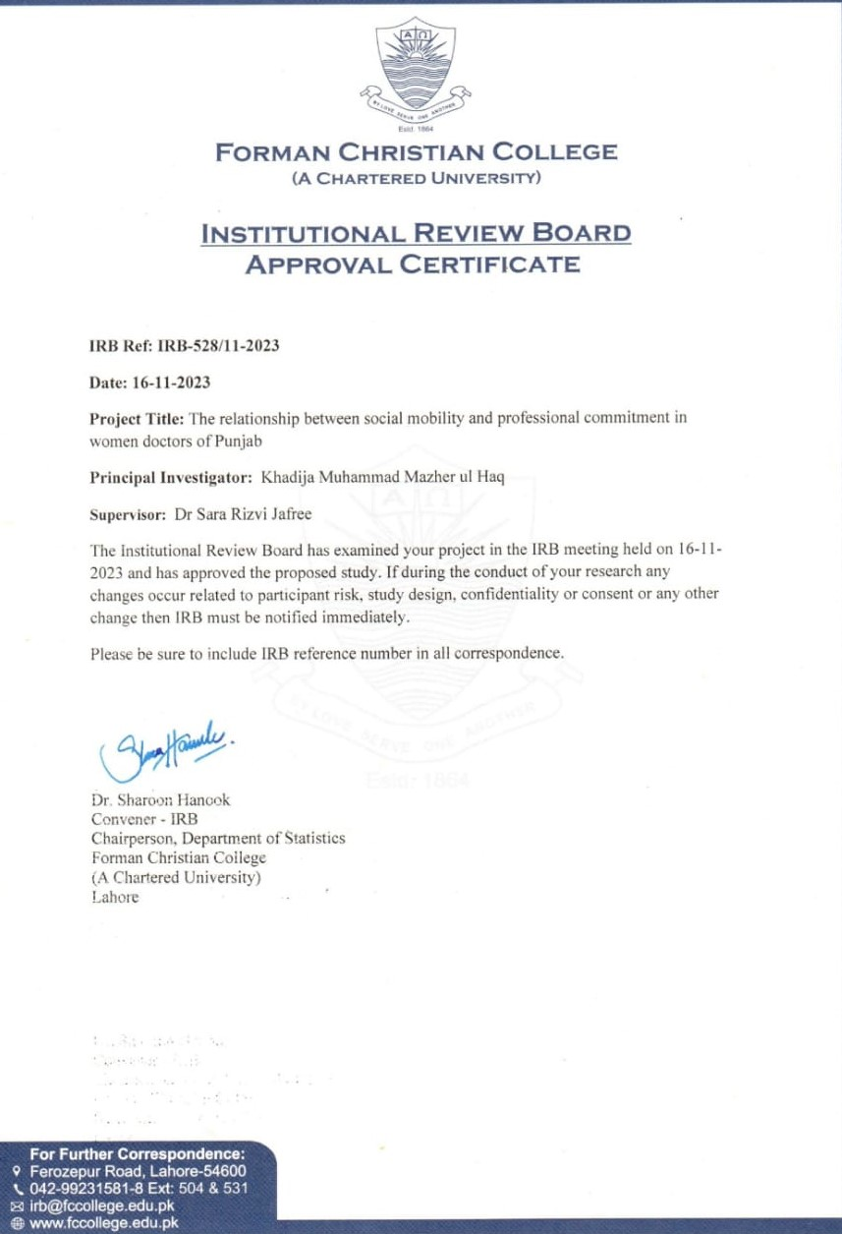

# Appendix B. Informed Consent Letter

I’m requesting you to participate in this research study which focuses on the relationship of social mobility and professional commitment in women doctors. The aim of this study to find out the challenges barriers and role burden conflict experienced by women doctors. This study will help to make improvements in social support policy interventions. In this study a questionnaire will be used for data collection for study-based research. This survey will be conducted anonymously, all responses will be kept confidential. You have the right to withdraw at any point from this study, you will participate as a volunteer, and this participation will not affect your position at your agency.

You are provided with a consent form for you to acknowledge your participation in this study. Your participation will help to understand the challenges and constraints faced by women doctors and we respect you be a part of this study.

Please sign below if you are willing to participate in this survey.

Signature of respondent: ___________________________________

Date: ________________________

**Researcher: Khadija Mazhar**

MPhil Scholar, Forman Christian College University

Email: [kam40128@gmail.com](mailto:kam40128@gmail.com)

Appendix C. Permission Letters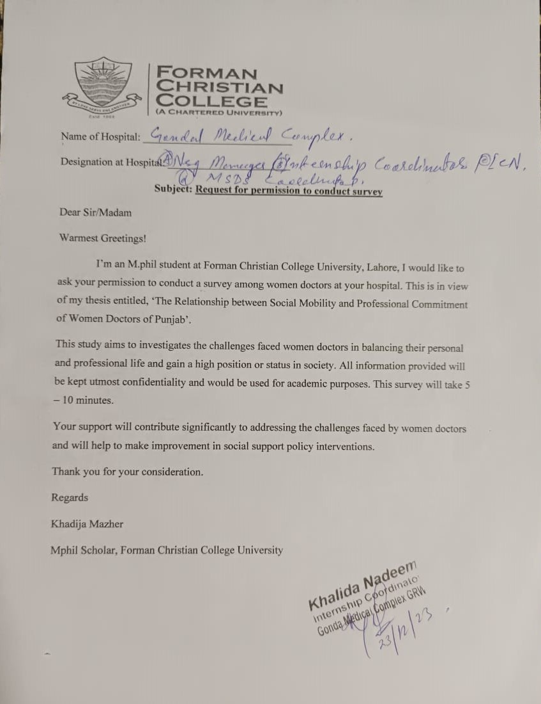

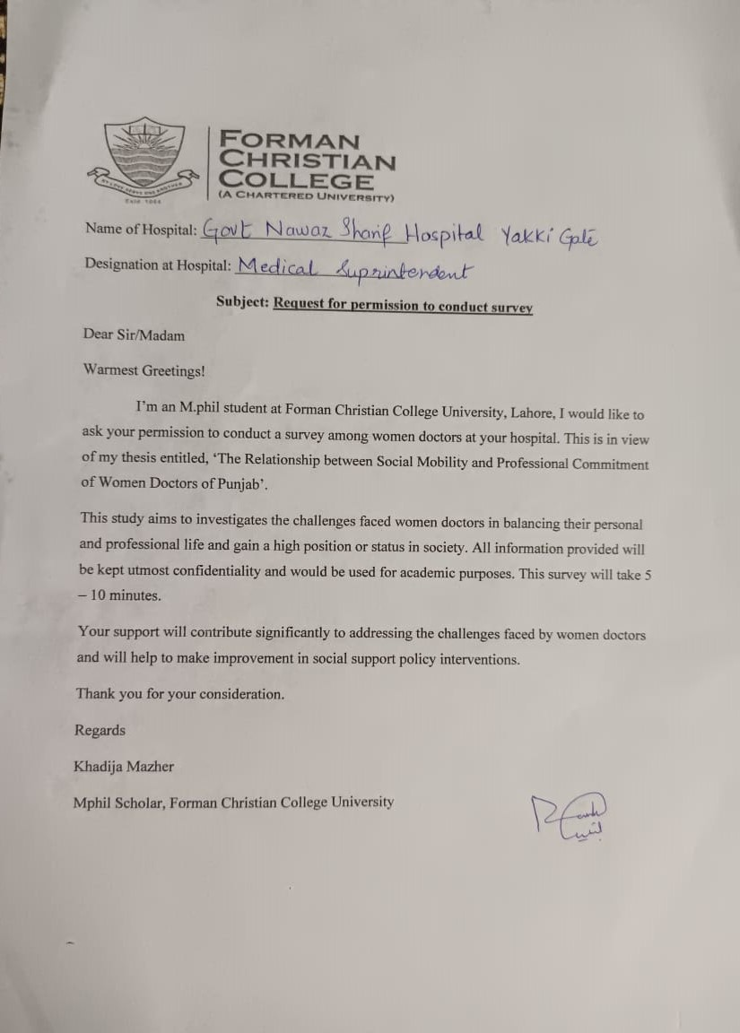

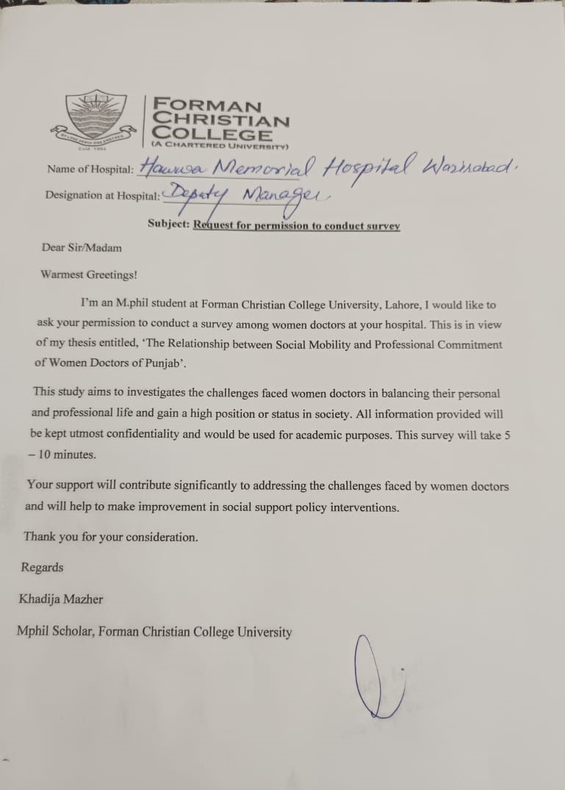

## **Appendix D. Questionnaire**

## **Section 1:** Sociodemographic

|  |  |  |
| --- | --- | --- |
| Sr No | Statement | Options |

|  |  |  |  |  |  |
| --- | --- | --- | --- | --- | --- |
| 1 | Age | 24 – 28 | 29 – 33 | 34 - 38 | 39 or Above |
| 2 | Marital Status | Unmarried | Married | Divorced | Widow |
| 3 | Children | 1 – 2 | 3 – 4 | 5 - 6 | None |
| 4 | Qualification | MBBS | FCPS |  |  |
| 5 | Agency | Public | Private |  |  |
| 6 | Designation at hospital |  |  |  |  |
| 7 | Residence | Rented | Owned |  |  |
| 8 | Working Hours per day | 4 – 5 | 5 – 6 | 6 - 7 | 7 – 8 |
| 9 | Currently Employed | Full time | Part-time |  |  |
| 10 | Family setting | Nuclear | Joint |  |  |

## **Section 2:** Social Mobility Scale (Browman et al., 2017)

|  |  |  |  |  |  |  |
| --- | --- | --- | --- | --- | --- | --- |
| Sr No. | Statement | Strongly Disagree  1 | Disagree  2 | Undecided  3 | Agree  4 | Strongly Agree  5 |
| 1 | Women can do things differently, but their status can’t really be changed. |  |  |  |  |  |
| 2 | Women, no matter who they are, can significantly change their status in society. |  |  |  |  |  |
| 3 | The status a woman has in society is something basic about them, and it can’t be changed very much. |  |  |  |  |  |
| 4 | Women can substantially change their status in society. |  |  |  |  |  |
| 5 | No matter what status a woman has in society at one point in their life, they can always change it a lot. |  |  |  |  |  |
| 6 | Women can change even their most basic status markers. |  |  |  |  |  |
| 7 | Women have a certain status in society, and there is not much that they can do to really change that. |  |  |  |  |  |
| 8 | As much as I hate to admit it, women can’t really change where they stand in society at large. |  |  |  |  |  |

## **Section 3:** Professional Commitment Scale by Meyer and colleagues (1993)

|  |  |  |  |  |  |  |
| --- | --- | --- | --- | --- | --- | --- |
| Sr NO. | Statement | Strongly Disagree  1 | Disagree  2 | Undecided  3 | Agree  4 | Strongly Agree  5 |
| 1 | Being a female doctor is important to my self-image |  |  |  |  |  |
| 2 | I regret having entered the medical profession |  |  |  |  |  |
| 3 | I am proud to be a female doctor |  |  |  |  |  |
| 4 | I dislike being a female doctor |  |  |  |  |  |
| 5 | I am enthusiastic about being a female doctor. |  |  |  |  |  |

## **Section 4:** The Work-Family Conflict Scale (WFC) by Netemeyer, Boles and McMurrian (1996)

|  |  |  |  |  |  |  |
| --- | --- | --- | --- | --- | --- | --- |
| Sr No | Statement | Strongly Disagree  1 | Disagree  2 | Undecided  3 | Agree  4 | Strongly Agree  5 |
| 1 | Being a doctor, the demands of my work interfere with my home and family life. |  |  |  |  |  |
| 2 | The amount of time my job takes up makes it difficult to fulfill family responsibilities. |  |  |  |  |  |
| 3 | Things I want to do at home do not get done because of the demands my job puts on me |  |  |  |  |  |
| 4 | My job produces strain that makes it difficult to fulfill family duties. |  |  |  |  |  |
| 5 | Due to work-related duties, I have to make changes to my plans for family activities. |  |  |  |  |  |
| 6 | Being a doctor, the demands of my work interfere with my home and family life. |  |  |  |  |  |
| 7 | The amount of time my job takes up makes it difficult to fulfill family responsibilities. |  |  |  |  |  |
| 8 | Things I want to do at home do not get done because of the demands my job puts on me. |  |  |  |  |  |
| 9 | My job produces strain that makes it difficult to fulfill family duties. |  |  |  |  |  |
| 10 | Due to work-related duties, I have to make changes to my plans for family activities. |  |  |  |  |  |